

Copyrighted

www.crownedanarchist.com rm@crownedanarchist.com

Girls Intelligent Agency

GIA’s mission statement as ordered by the United States Intelligence Community (http://www.intelligence.gov):

“The Girls Intelligent Agency shall provide the President and the National Security Council with the necessary information on which to base decisions concerning the conduct and development of foreign, defense and economic policy, and the protection of United States national interests from foreign security threats.”

Following the recent terrorist attacks, the United States Intelligence Community decided to create a new agency regrouping top women experts from the main community members. This concealed Special Force unit is based in the Area 51 Research Center for New Technology. It is responsible for bringing together the work and knowledge of the different US government intelligence agencies in order to form a global picture of the national threats from rogue states and terrorist organizations, and also develop counterattacks and prevention against these threats.

In the intelligence milieu it is proven that women are better at spying, gathering top secret information and manipulate their way to success than men. The fate of national security has been entrusted to nine elite women known only to a small number of top reigning government security officials and supervised by one man from the US Intelligence Community. This slick undercover and proficient group of exceptionally skilled covert operations squad is secretly referred to as the GIA.

They are responsible for the extreme missions turned down by the different US espionage agencies that stamped these cases as "impossible". The stealth-elitist squad known as the GIA then seeks the impossible solutions where the end does justify the means.

The GIA is an intricate action-thriller inspired by Mission Impossible, the hit television series from the 1960s and 70s. The televised series is a continuous cliffhanger that completes one mission per season though each episode has many specific tasks to be accomplished to get the audience closer to the truth.

Special Operation’s Intelligence requires that the nine GIA agents are paired off in groups of two in case one of them is killed or incapacitated and not able to fulfill the mission. They also have access to new high-tech devices derived from back engineering alien technology found over the years and developed by a secret military research facility in Area 51. Each member reports to the person responsible of the intelligence agency they represent and together they devise plans to stop the major threats to national security.

The GIA superior squad of intelligence operatives is handed a hard-hitting assignment that on its own poses an enormous test of wit and superior technical skill, which has now become even more challenging due to the fact that a mole has been reported to be amongst the elite GIA.

Viewers will have to decide week after week as the details of the mission unfold who the mole could possibly be. This will prove to be a mission within the mission allowing the viewing audience to participate in the interactive competition challenge to discover the mole’s identity which will be revealed on the final episode of the season.

Mission

The first mission of the GIA is to bring together their talents to identify and eliminate what appears to be a diabolical plan brewing on the exotic tropical island of Cuba which could cause global destruction. Intelligence sources are detecting a possible group of government-supported terrorists attempting to smuggle and develop a biological weapon of mass destruction on to the Island.

From an extensive list the GIA needs to identify all the parties involved as the mission progresses. They will need to investigate and steal intelligence from the governments currently trading and doing business with the Island and its infamous leader. Finally they have to uncover the main players developing the weapon and stop them in time.

It’s been rumored that the leader of Cuba is in ill health and so it would be easy for a military dictatorship or the like to bring another world leader to honor him before his health fails. The GIA needs to prevent a new tyrant from taking power, especially one from these rogue states developing biological warfare.

The GIA approaches involve technical hardware, disguises, diversions and Trojan-horse-style infiltrations, usually executed in a nonviolent manner so as not to attract attention. Our nine women are accomplished soldiers, engineers, pilots of new stealth ships and specialists in advanced training. They use data from their respective intelligence agencies to come up with elaborate ways to achieve their goal and surprise their victims and the audience alike.

The Girls Intelligent Agency is a stealth action adventure mystery featuring an incredible arsenal of sophisticated weaponry, high-tech gadgets and mind blowing nonstop action and suspense. The ongoing mission has enough twists and surprises to keep audiences guessing until the last minute.

The espionage game is brought to another level of intelligence mixing action and adventure in brilliantly executed action sequences and cutting-edge techno-thrills involving careful thinking. If you’re hot for suspense, GIA will light your fuse and put you on the edge of your seat.

GIA is a smart, ambitious and elegant thriller involving top intelligence and beautiful agents fighting for power and knowledge accompanied by a breathless and exciting finale. They cannot fail under any circumstances.
GIA AGENTS


GIA Coordinator, The Lucky Charm

Each GIA agent represents a member of the US Intelligence Community (http://www.intelligence.gov/1-members.shtml). They were brought together by one young man from the IC who supervises the day to day running of the agency even though he is more like a nerd who suffers under the wrath of these nine strong minded women agents struggling for power, knowledge and action. He will sometimes be involved in the mission only to prove that he is useless and weak compared with the agents. Some of them will dislike him for being a man and treat him accordingly, while others will consider him the lucky charm of the team. This is why his undercover name is the Lucky Charm.


GIA Agent Havanashores
Her keen tactical sense has rewarded her an undercover security and intelligence position for the POTUS unit.

Reports to the President of the United States.

As the direct link to the President, agent Havanashores is full of herself and has access to knowledge only the President knows. She believes she is in charge and ultimately she is because only her has the power to give the go ahead to anything they are planning. Unfortunately she is not too popular with the women representing the FBI and the CIA as they too believe they are powerful and should be part of the decision process. She is the main agent at the GIA.

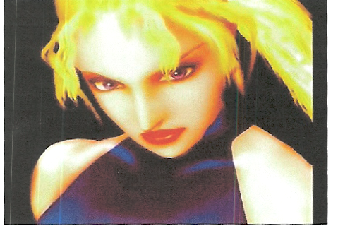
GIA Agent Misstique
A clever government informant that specializes in international interrogations.

Reports to the Central Intelligence Agency (CIA).

Agent Misstique often comes head to head with agents Havanashores and MadamTiger when the time comes to decide the right course of action. She is a main player in the organization and believes the CIA should be acting on her own rights independently from the other intelligence agencies. She is very good at her job following years of experience in interrogating prisoners and other criminals, but her charms are not working too well within the agency. She appears to be suspecting everyone of foul play and keeps interrogating the other agents about their motivations.
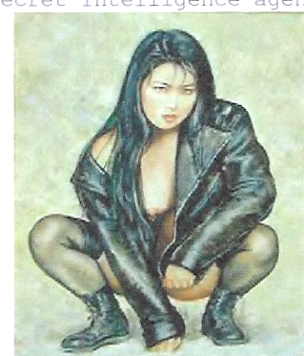
GIA Agent MadamTiger
A savvy no nonsense agent for the anti-terrorist intelligence unit.

Reports to the Federal Bureau of Investigation (FBI).

Agent MadamTiger believes she knows best as she is sitting on the most up to date information against terrorist threats. As an essential member of the Girls Intelligent Agency she is capable of coming up with the most complicated ways to obtain what she desires. She is responsible for most tactical decisions and operations. She is the brain behind making the impossible come true.

GIA Agent Mochasoul
She’s a matter of fact specialty agent who works strictly undercover for the government’s special assignment forces.

Reports to the Department of Homeland Security (DHS): Information Analysis and Infrastructure Protection Directorate (IAIP).

Agent Mochasoul is working for the Department of Homeland Security, more specifically for the Terrorist Threat Integration Center (TTIC). She has become over time their best agent in the field, successfully going undercover to seduce important terrorists into revealing their intentions. Despite her angelic air she’s not afraid of anything.

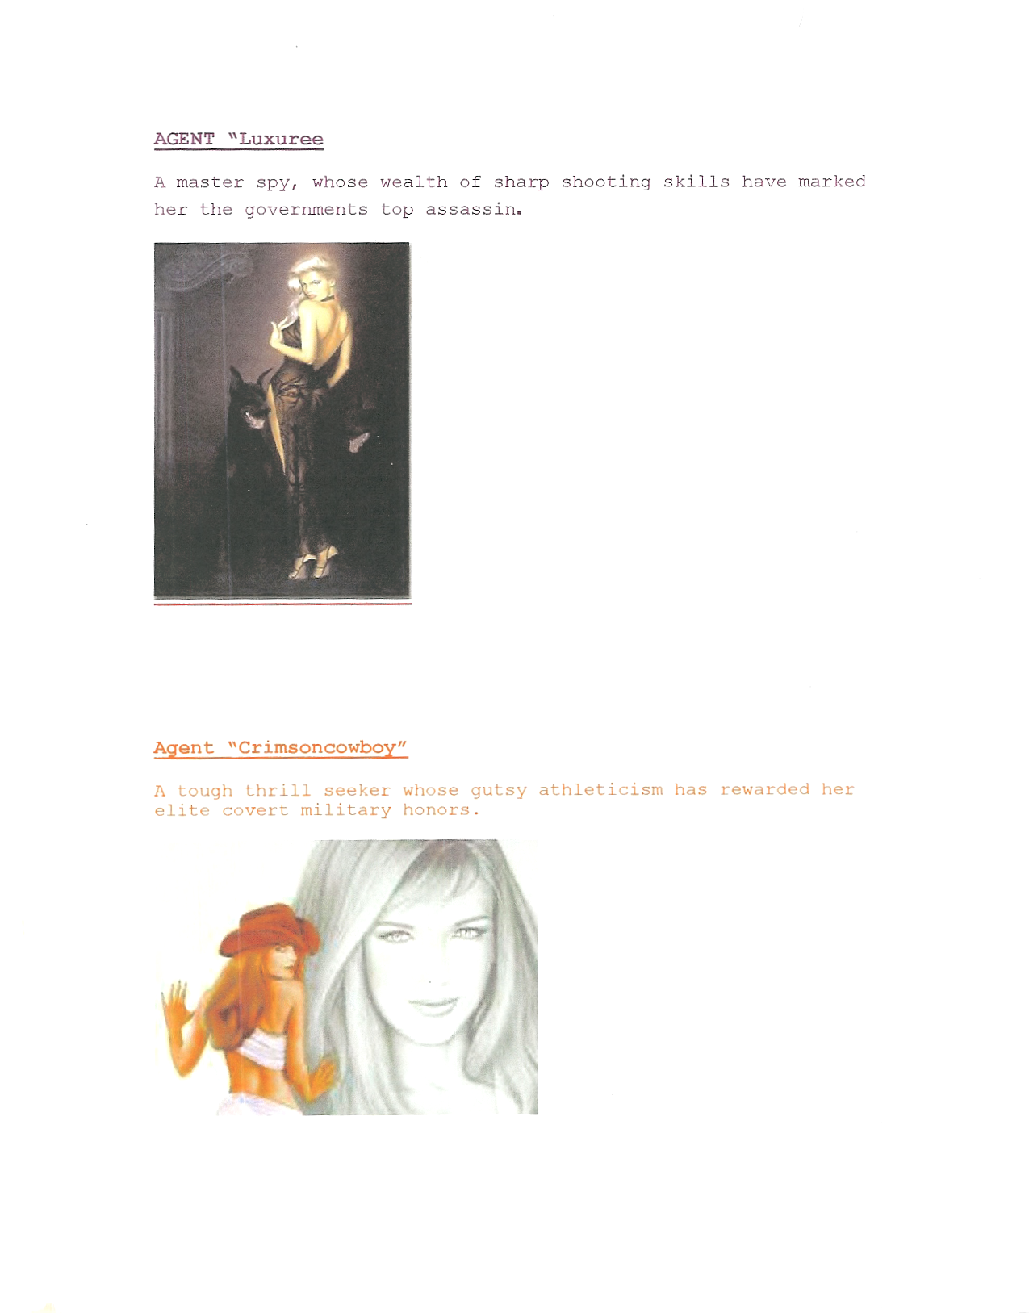

GIA Agent Luxury
A master spy whose wealth of sharp shooting skills have marked her the governments top assassin.

Reports to the Department of State: Bureau of Intelligence and Research (INR).

Agent Luxury excels in the diplomatic circles as many foreign dignitaries could testify if they were still alive today. Reporting to the United States Secretary of States she can pinpoint any diplomat and their background, she is also willing to kill more than one for the mission. She claims to be the only agent with a license to kill and specializes in high profile murders.


GIA Agents The Gemini Twins… 2 of only 3
MILSTAR Military - Strategic, Tactical Satellite Intelligence agents in the world

Report to the National Reconnaissance Office (NRO) and the National Geospatial-Intelligence Agency (NGA).

The Gemini Twins agents can surprise more than one victim by being at two places at the same time and attacking in pairs. They are the nation’s eyes and ears in space and developed the revolutionary satellite reconnaissance systems of the NRO. Their specialty is to provide timely, relevant, and accurate geospatial intelligence derived by the exploitation and analysis of imagery and geospatial information. They describe, assess, and visually depict physical features and geographically referenced activities on the Earth. In two words they can find the enemies wherever they are in the world and locate any suspect installation.

GIA Agent Crimson
A tough spunky thrill seeker whose gutsy athleticism has rewarded her elite covert military honors.

Reports to the Defense Intelligence Agency (DIA).

Agent Crimson represents the four military services in the Department of Defense: the Army Intelligence, the Air Force Intelligence, the Navy Intelligence and the Marine Corps Intelligence. She feels that she is the practical one because she has many years of army experience in all four military services. She uses brutal force, she prefers physical combat to any kind of intelligent ways to gather information. She believes in torture and provoking fear to get the information from prisoners. Left to her own devices she would easily violate every single right of the US Bill of Rights. She needs to be kept in check, constantly reminded of the law and that it also applies to the rest of the world.

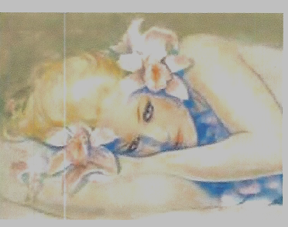
GIA Agent Passionflower
A cool, calm Harvard grad turned Pentagon Internet security specialists.

Reports to the National Security Agency (NSA).

Agent Passionflower, under her innocent expression, is the technical mind of the mission. She specializes in high-technology, information technology, communications and cryptology. As such she coordinates, directs and performs highly specialized activities to produce foreign intelligence information and protect US information systems. She is fluent in many foreign languages and has the ability to understand the secret communications of our foreign adversaries. She’s up to date with the latest high-tech gadgets developed by the Area 51 Research Center but somehow she always fails to give all the right information to the agents, causing havoc in the field.

Roland Michel Tremblay, Writer

44E The Grove, Isleworth, Middlesex, London, TW7 4JF, United Kingdom
Tel: +44 (0)20 8847 5586 Mobile: +44 (0)794 127 1010

http://www.crownedanarchist.com rm@crownedanarchist.com

